YAMAHA XR 565 MATRIX

12 Pin Connector
Black Cable on PIN 11
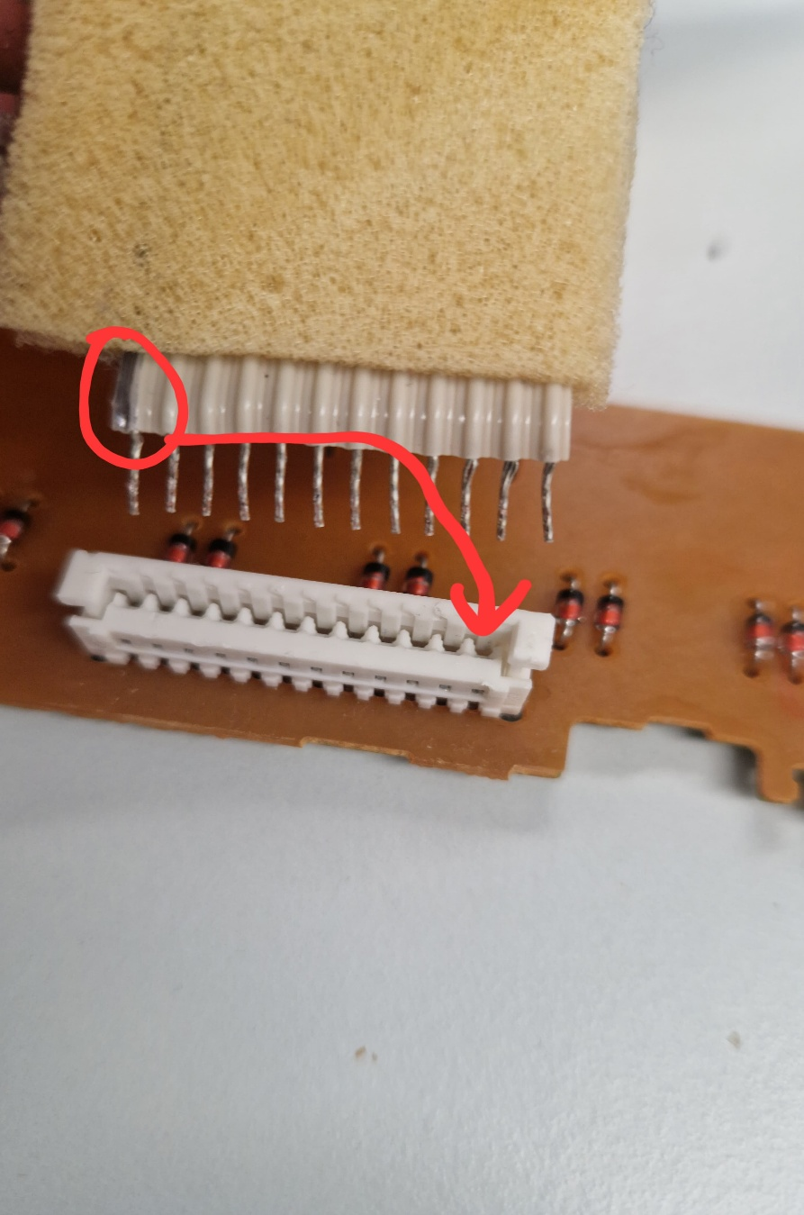
All Pushing power through
5 Pin Connector
Black Cable on PIN 28
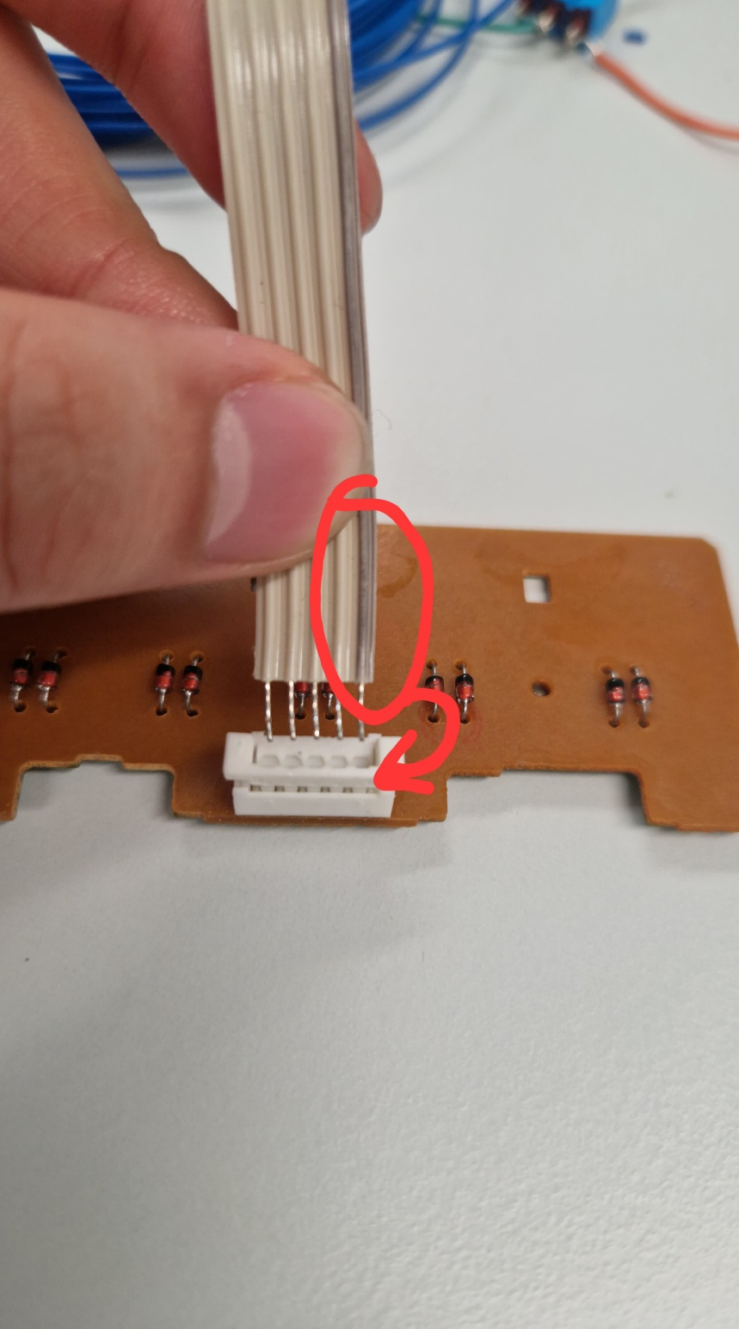
LOW PULL

